The open lecture of UNU on January18, 2025

※Title: Planning for an Uncertain Future: Environmental planning strategies Habitat Adaptation

※ Dr. Christina von Haaren (professor at Leibniz University) with Dr. Sawako Shirahase

※ Key Message: To me, it was like how to make the power of science for the solution of SDGs in practical way.

※I picked next words which I think they have key message from the both of professors.

:uncertainty,science make a business, communicate how much certainty is enough ( in other words they are very demanded　or not), Open pluralistic society,constant examination, conceptual frame works for international landscape planning,Data is important, “philosophy” is important,citizens acceptability important,legal protection,criteria,baseless and lot of competition, prioritize, high legitimacy. Low unspecified,guardrail(予算や時間・品質などの制限をさすことが多い）of sustainability、Try and error adaptation,1.5% inside guard rails of sustainability.**Geo Data (地理情報システムで格納された地理的位置情報）**

※ I got next messages from this lecture.

1. We have to remember science is not “certain”. 2) Dr. Christina said the error adaptation is important. For that 1.5% of inside guardrail maybe practical way to save this uncertainty.
2. So, it becomes important to keep having right way with citizens important.
3. So, Scientists need to make “Good Data system which is open to the public” is very important.

※My impression: English peed was so high, and those people int the floor were so distinguished

（著名な ）and profesionas, ちょっと場違いで、今回は理解不可能かも・・・、そう思って参加しましたが、あにはからんｙ、きちんと、大切なメッセージをとれたことに、自信をふかめております。これもCCAJ 活動のおかげさまだと、深く感謝しております。

昨日は、立川さんが、一緒に参加してくれました。ありがとうございました。

January 19, 2025

　　　　　　　　　　　　　　　　　　　　　　　　　　　　　　　Kyoko Kumada

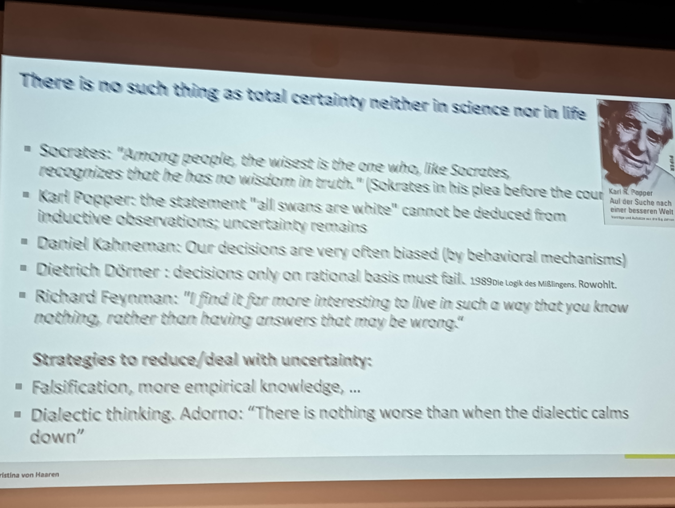追伸：写真を撮るの忘れましたので。講座の写真をおくります。



