[UNU TICAD Thematic Events] August 20,2025

*Title: “Artificial Intelligence and Higher Education in Africa”

*Speaker: Prof. Tshilidzi Marwala (UNU), Prof. Atsufumi Yokoi(UNESCO Chair),

Ms. Hanan Fadlon(Consultant;Psychology and AI) 他

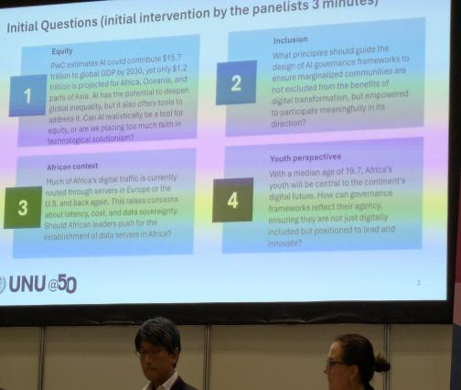

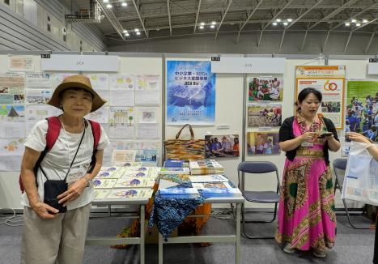

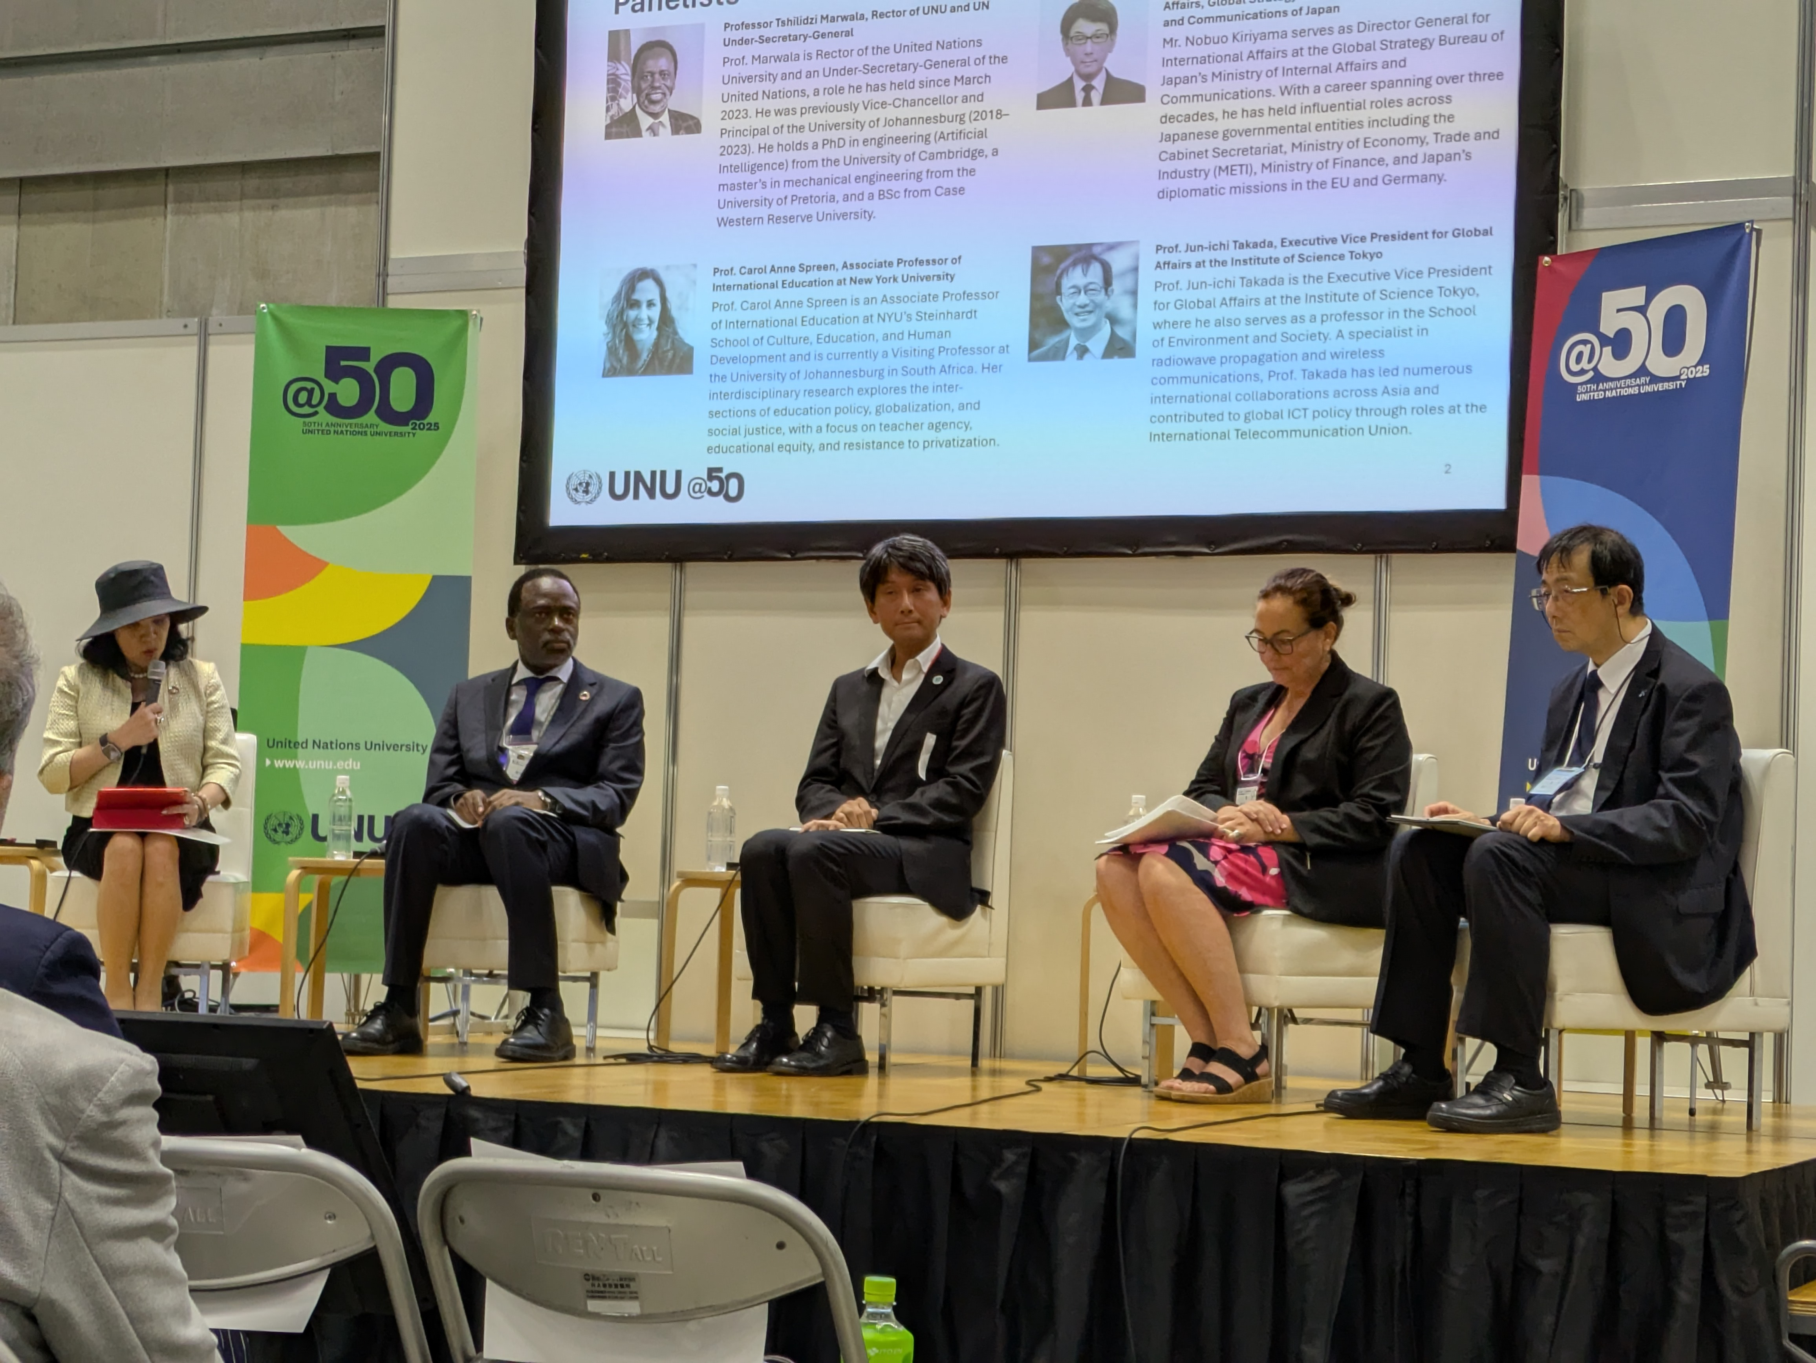

*”**General message”**:The power of AI for Higher Education is enormous.

*”**Security**”But from the security and ethical point of view , we must have the effective protection system against for misuse and abuse.

*From that point of view interesting 2 explanations in this lecture.1) Prof. Tshilidzi : AI makes mistakes.That is why human being needs to learn more and keep being prepare for that. 2) Prof. Yokoi: He stressed on human philosophical point of view which is UNESCO’s focus. He introduced what UNESCO did and doing in the world.

今回の出席は、渋谷さんと2人だけでしたが、TICADのすばらしさを実感する良い機会でした。

渋谷さんが積極的に取ってくれたJICAの前での写真、世界の職業、仕事に関心のある、第一学院高等学校の皆さんにも、JICAの仕事を紹介する材料になると思います。

August 21,2025　　　　　　　　　　　　　　　　　　　Kyoko Kumada