The report from UNU open class on May 8th

\***The Title:** Aligning Intelligence with Purpose :Egypt's Vision for Expressible and Inclusive AI

*guest **speake**r ;H.E. Dr. Amr Talaat （エジプトの通信技術大臣/アムル・タラート閣下with Mr. Michael Baldock(UNU chief stuff)

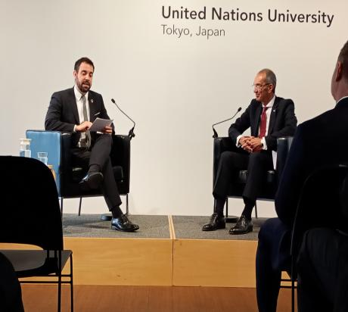

The picture above is Dr Talaat(right) with Mr. Michael Baldock(left)

**\***Summary of general message

:As a leader of TICAD and UNUCEF, Dr. Talaart’s focus of Digital strategy ;human centrism digital frame work was very clear and attractive lecture.

**\*** He explained by using the concept of ICD(Implantable Cardioverter Defibrillator:埋め込み型除細動器）and EI(emotional Intelligence).

.Egypt as a leader of whole African countries,(African friends and Arab friends). is trying to make very effective organization of body based on cross religions, all solution for application based on both academic and abstract matter focusing on agriculture, healthcare and so on.

**\* My interesting point is that he focus on “data”.**

In short how to use that enormous data with whole African friends effectively and in fair way based on human- centric and philosophical way.

昨日は、渋谷さんと二人だけの出席でした。今、私たちがタイム誌で追いかけている、デジタル問題。

リスクと利益をどうバランスをとっていくか？　その問題についての、最新の動き、ニュースが、アフリカの方から入ってくるということに、びっくりし興味を覚えております。

２０２５年　　　５月８日　　　　　　　　　　　　　　　　　　　　　　　　　熊田強子