The report from UNU open class on July 29,2025

*Title title: **“Diplomacy in Transition: Women in Leadership”**

*3 gust speakers with Prof. Sawako Shirahase

1)Ms Mami Mizutori（東北大学・UNDRR;U.N.Office for Disaster Risk Reduction;国連防災戦力事務局）

2)H.E. Ambassador Shorna・Kay M. Richards（Ambassador of Jamaica to Japan）ジャマイカ

3)H.E.Ambassador Melba Pria(メキシコ大使‐日本大使館）

Ms. Mami Mizutori H.E.（閣下、尊敬） Ambassador　Kay M. Richards　H.E.　Ambassador Melba Pria

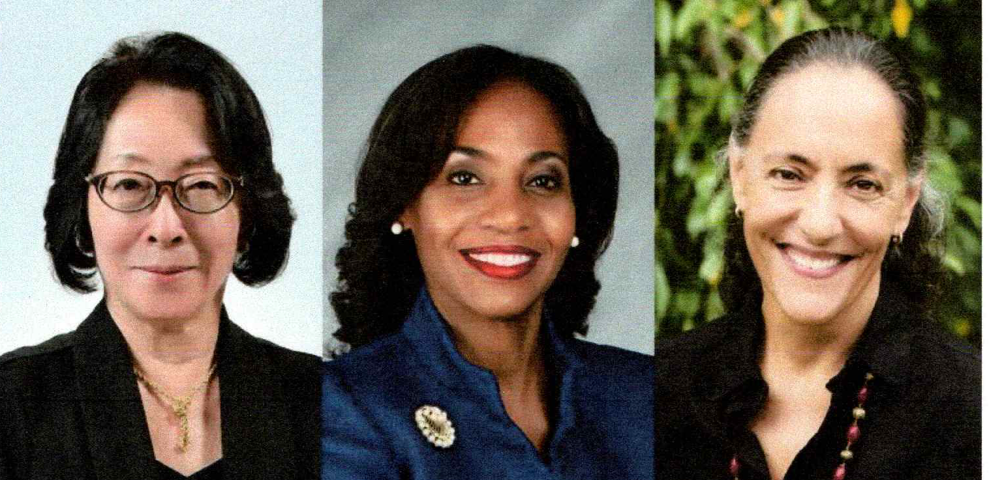

＊Key message

A)**General information**.: The history of the movement of gender issue is pretty long but the number of women stuff in important institutions is keep being tremendously small. The problem is especially Japan is far behind(We can see that from its number.) the world.

B)**Facts:** a) Gender equality Headquarters are made in 1994. b) The number of President ,Ambassadors or other important position are increased now but it is still extremely small.

C)a) **Message from Ms Mami Mizutori:** Where she worked for UNDDR, even the role of women workers were so important, they were no decision making position. b) **Message from Ambassador from Jamaica:** The role of women for Nobel Prize winning was so important. Their activity as a KATARIBE(narration for physical and emotional description of experience as victim were so special and had a strong power. c) **Message from Ambassador Melba Pr**ia: Education from kindergarten is important.Please tell them “Be active and have their own opinion. Not to tell them”Be quiet!! And just follow others.”

1. My impression about the topic:いつもと違う、5階のエリザベス　ホールで、５０人ほどの参加者でした。

７人ほどの男性参加者たちに、brave participants と　ユーモアたっぷりに呼びかけられ、大変楽しい雰囲気ながらも、厳しい現実と、問題点の指摘、力強い励ましを参者達は、一様に感じたようでした。

次回は、”若者の参加をいかに呼び込むか”のテーマです。

楽しみにしていただければと思います。

July 20.2025

Kyoko Kumada