The report from UNU open class on Feb.13th in 2025
*title:”Future of Innovation and creativity in transforming world”
*Daren Tang:WIPO（World Intelligence Property Organization)の事務局長
WIPO is located in Geneva Switzerland and it has 193 member-states 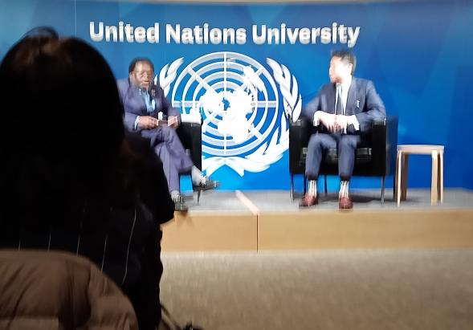
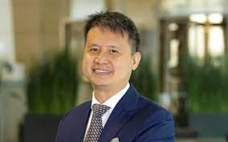

*My short summary and impression
: Intelligence property are patents, copyrights, industrial design rights, trademarks,geographical indications and some jurisdictions and trade secrets.The role of all of them are so important to modern and future economy.
The scale is so big and complicated.
: To question “Digital disparity,Mr. Tang’s answer was so interesting. The movement and activity in the rising countries are so big and strong.
For example Rwanda’s small shop owners and their Agribusiness.
I just can’t write here, but so many countries which are not familiar to us usually are so active. That was a big surprise.,
There are so many things which are very active but just we don’ realize it. Among them there are many Japanese local specialties (特産物）.
That was a big surprise.,
渋谷さんがお書きなったように、わくわくするような発見がたくさんあるような講座でした。 Kyoko Kumada

