The UN on July15th in 2025

*Title:”Sowing Equality:Addressing Gender barriers in Food, Water and Agricultural Systems”

*the speaker Dr. Nidhi Nagabhattla (UNU-CRIS) with Dr. Sawako Shirahase

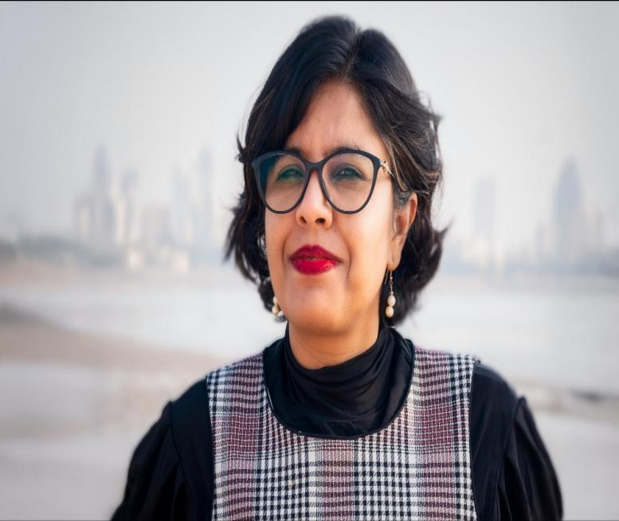

Dr. Nidhi Nagabbattla with Dr. Sawako Shirahase

**\***Key message; The importance of making women equal access to **Farm management**, **Land ownership** and **Agriculture research the global sustainability especially “Food”.**

* **List of words show her point of view and what is the reality.**

Evidence backing policies, sea weed farm, gender dynamics, full system components,aqua culture,lack of data collection,many complex challenges.

\***Interesting information**: 1) About “what are the first thing which women need now?”The answer is technical and financial education.Because,women’s access to credit market(finance)is important.2)The area she focused is the East Asia where it has biggest number of women victims. She compared the situation about,Denmark, South African and some South America.

*On Line の講座でしたが、Web 技術の進歩で、国連に行ったように自然に、参加できました。ぜひ皆様の参加をおすすめいたします。　　　　　くまだ