UNU open class on October 9,2024

Title: **“International Academic Cooperation in a geopolitically changing world”**

Lecturer:Bonn university rector “Michael Hoch

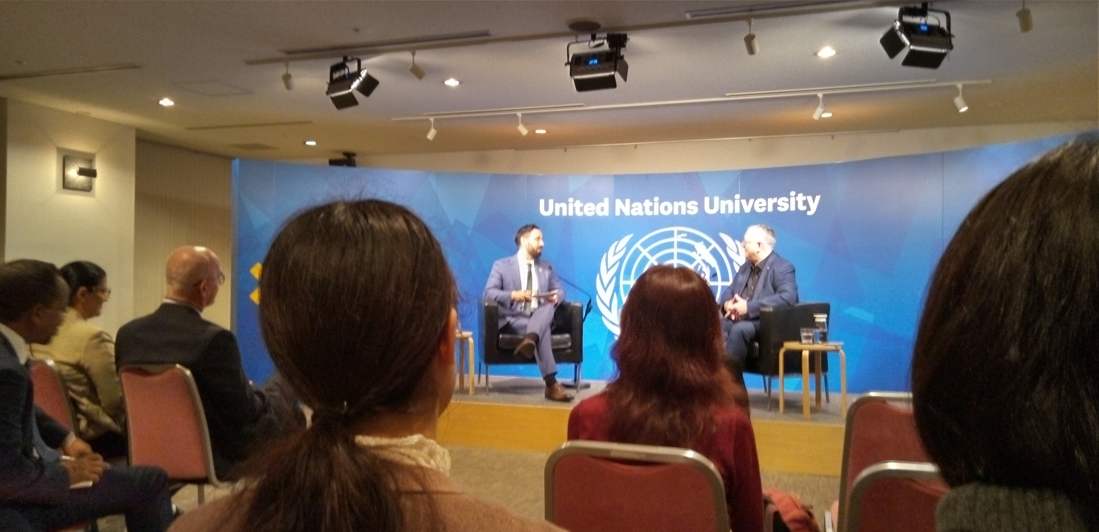

**Rector Michael Hock with UNU Michael Baldock**

**※key message 1) general point of view**;when “Nationalistic movement is stronger and stronger,the importance of international academic cooperation has never been more important like today. How to balance security is a big challenge.Since big organization or institution is difficult to be keep being open, **more individual** focus becomes important. Because of building trust worthy relation ship becomes fundamental power.

**２**）**Facts and words from this lecture :**a) 20years experience of 2~3 weeks exchange student between Germany and Tokyo University is successful. b) Because of different democracy index(民主主義の指針・指標）、we need to approach Individual(friends). c)We need to enlarge body and level off institutions.d)concrete example and research security,all different section like “Technology”, data approach are key focus.

**※**昨日は、渋谷サンと熊田の2人だけの出席でしたが、現時点での高等教育の様子がよくわかる点で興味深い勉強になりました。