The report from UNU open lecture on November 14th 2024

\***Title**: Trends and Development in Global Health in Africa

* Guest Speaker: **Professor Wim de Villiers** (Rector and Vice chancellor of Stellenbosch University, South Africa)

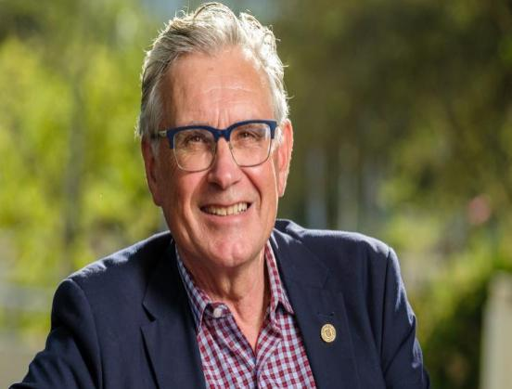

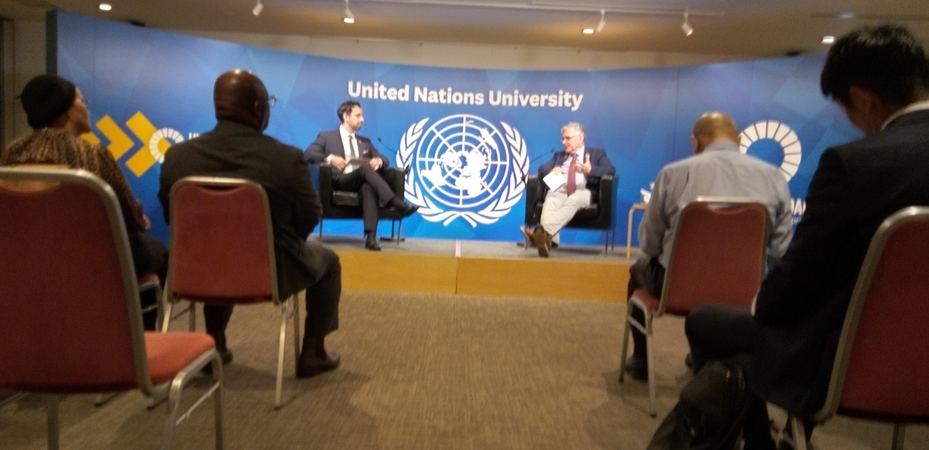

Above: At the UNU headquarter Shibuya prof. Wim de Villiers

*My summary are next 3 points.

1. **Comprehensive message**: Diaspora’s leadership is seems to be making a very positive progress in global health in Africa. Because of his(Dr. Wim) background in South Africa, Britain and America, his point of the movement for the African role of the importance is so persuasive.
2. **Facts:** a) In South Africa , there is big active and high level research institution which are connected with Britain and America on data, information,friendship and so on.

b) Today, in South Africa, basic health care is enough only for 16% of whole population of 600million. That is too small. c)Nigeria and Cameroon need to have basic health infrastructure for like HIV and Tuberculosis. There are so many preventable diseases. That is a reality,now.

1. **Future:**There is a growing movement of African role as a important part in the global health.

武内先生の御講座につながる様な情報がたくさんあったように、感じております。

昨日は、渋谷さんと私だけの出席でしたが、貴重な興味深い体験になりました。

　　　　　　　　　　　　　　　　　　　　　　　11月15日

　　　　　　　　　　　　　　　　　　　　　　　　　　　　　熊田強子