UNU open class on January 10th,2024

*Title; “Multilateral governance and Artificial Intelligence”

*Speaker; Prof. Shiro Armstrong with Prof. Sawako Shirahase

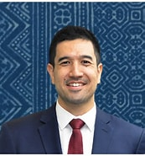Prof. Shiro Armstrong

* Key message;introduction of Prof. Armstrong’s theory for digital economy and policy dilemmas(two way approach).Mainly **multilateral governance**(as a business form it becomes small groups which is multilateral) and **DPI**(Digital Public Infrastructure).

My summary is next 3 points.

1. Nature of digital economy: distance is not matter,importance of data, market concentration brings winner takes biggest return,lack of transparency bring risks,protection from government misuse become important.
2. **DPI** is necessary for protecting “Principle”.(What is higher priority we have to share and what is we shouldn’t miss.), knowledge economy and digital economy.
3. G20 united nations are moving to use same principle.

この講座は、次回のタイム誌の課題と共通している点があると思いましたので、興味深くききました。今回は予定が詰まっていたので、on line でききましたが、**デジタル経済への世界の対応**が、初めて実感として伝わってきました。

July 12, 2024

Kyoko Kumada