**\*The report from UNU open lecture on Feb. 20, 2024**

*Title:”Why Combating Desertification(砂漠化） crucial for Human Security?With Mr. Ibrahim Thiaw”

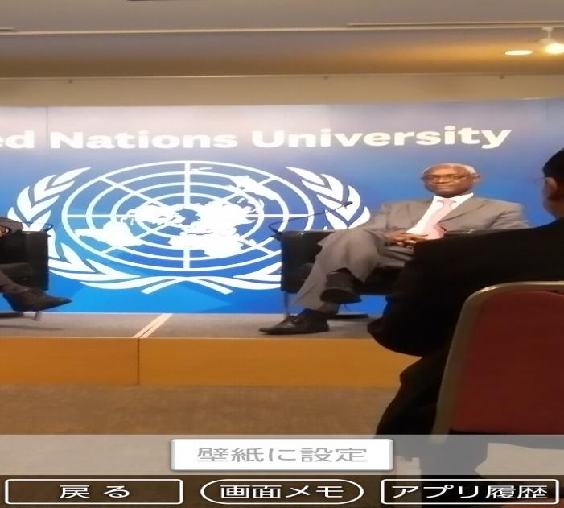 (Mr. Ibrahim Thiaw)

* The key messaage with 3 points of summary: Why Desertification is important is that “Food Sucurity” is the No1 issue for the humanbeing in many ways. So, according to him Agriculture became the most biggest focus. **One**; An efficient management of Agriculture with best Technology and science will be the good strategy. **Two**; “Good Business Mind”and sytem become important for avoiding “complicated hidden BURAEUCRACY(官僚主義）".**Three**;To make practical and accessable job making for indivisual (espcealy young people) is important.

*My impression from this lecture; Since Mr. Ibrahim has been working as a directore of Sub Sahara area long time and had a rich experince his approach reflected to me as a very down to earth approach based on fresh and creative idea. ケニア、ガーナそして南アフリカにおける、調査・活動報告が力強く、そして興味深く感じられました。

Feb. 28,　2014

　　　　　　　　　　　　　　　　　　　　　　　　　　　　　　　　　Kyoko Kumada