The report from UNU open class on September 4,2024

※ **Title: “The importance of Greening Logistics Industry”**

**※ Speaker:Tony Khan (DHL Japan:Global leader of Logistics companies)with**

**Prof. Tschilidzi (UNU Rector)**

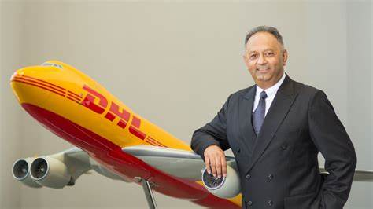Mr. Tony Khan

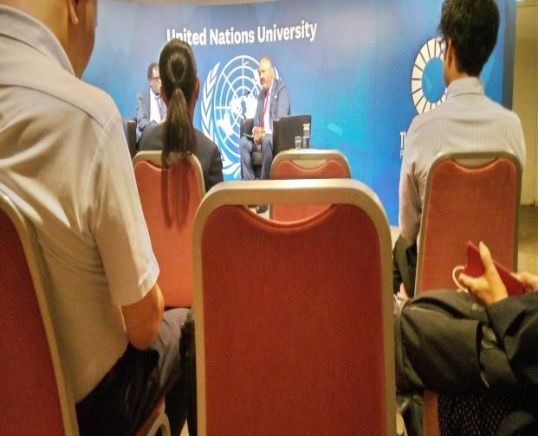

**※**General message based on facts:

1. The impact of　”Logistics Business” is so big. You can see that the fact that the size of global logistics is 11% of whole global business(combining America, EU and Japan).
2. Very profitable with big job creation.:$5billion in 2023 and with good prospect in 2030.
3. Very innovative.:DHL is the first company who has already 12 electric aircraft.And all kind of very innovative business approach.

4）DHL has Big and Friendly Global Network :COP 28 networks, DHO(DHO means ドリブルしながらパスをする） group(email link like industries and Real Estates~,MBA students.

**※**出席者の感想です：The Speaker ;Mr. Tony Khan was so talented communicator with warm heart and keen BUSINESS mind.そんな会場の雰囲気に便乗して、熊田も手をあげて、5番目の質問に参加させてもらいました。３回目のトライでしたが、とても良い経験になりました。

今回は、渋谷さんも旅行中で、他の会員も多忙のため、熊田だけの出席でしたが次回を又楽しみにしております。

September 6,2024Dasley, Hillblom,and Lynn

Kyoko Kumada

1. S:DHL stands for the name of founders of DHL ; Dasley, Hillblom,and Lynn who started it in 1969 in Francisco.