The report from UNU open class on May 10,2024

\*Title: “Agile Roboitcs and AI for future”

\*Speaker : Giuseppe Loianno (Assistan tprofessor of New York Universtity

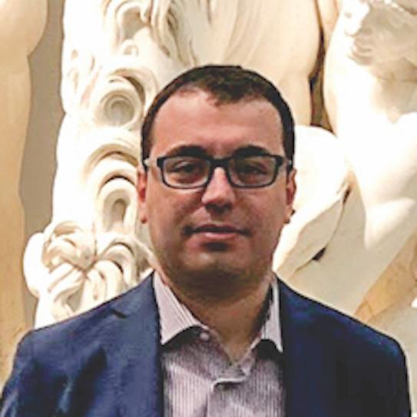DR. Giuseppe Loianno

\*Overall Key message: First of all it was so interesting to hear the voice of world’ top level specialist directly on the role of AI to the real world now and future.He was so eloquent and spoke high speed English with atrong accent endlessly with happy stmosphere as if he was talking with his close friends. His information was so close and real based on daily facts.

My summary is next 4points.

1. The light side of AI.(AIの明るい面）： It bring the system of “collaboratin”(合作・協力） in great scale

with being connected in extreamlly complex and deeper way.

1. The shade.（影・問題）：It can manipulate(操作する）,exploit（悪用する） easier.
2. The list of what AI can do: making decision, searching rescue, several obligation, mutiple robot, not personalize,automation, completely and basically scan in much faster way,excellent database, refunishing, corrrespondence, monitoring,transportation, joint physically inter connected~ in those cases. It brings huge success.
3. Business(仕事の形）:Cooking, cleaning, companion, more personalized cedecine, education and so on.
4. My impression; 高いレベルのデジタルやAIの講座は、なかなか直接参加することができないので、今回も本当に貴重な経験になりました。AI が社会や私たちの生活にどんな風に組み込まれていくのか、その構造的な仕組みを感じることができたように思います。

今回は、スケジュールの関係で、熊田一人の参加になりましたが、英語としても、リスニングの素晴らしいtrainingになったように思います。すわっ祭や、風邪をひいたりして遅くなりましたレポート提出ですが、ぜひ読んでいいただけたら嬉しいです。

May 21,2024

Kyoko Kumada