The report from UNU open class on March 4,2024

＊Title: **Japan ASEAN Bridges Event Series : A Financial Approach to Climate Risk**

＊Speaker: **Prof. Robert F. Engle Ⅲ（Norbel Laureate；ノーベル賞受賞者）**

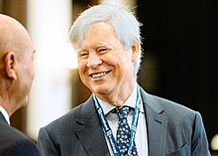 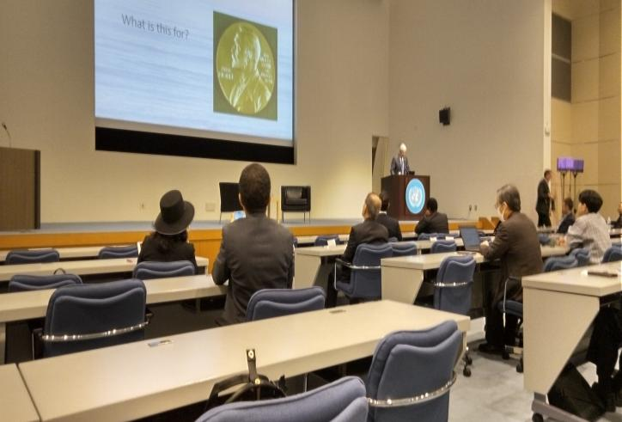

Pictue above:Prof. Engel Engel Ⅲ　　　　　　　　　　国連大学の会場

＊　**Key message　:** It was about introduction for the UN strategy against Climate risk focusing on “Finance”.

Next 3 points are the specific ways(具体例です）.

1. **Cooperation among world’s power of politics, academia, business becomes importan**t. We now see that the movement of　UN hosting international peace funding（example;ユネスコ）,relating movement by using **Fintech（フインテック;金融技術）**and etc. What do you see tody,stock market？Here are the hot spots in the world like in Egypt, China and so on. Professer continues to point what is happening in the world.
2. It is important to **see climate risk from long run**. **Science is pretty accurate and certain so, we can change our behavoir depend on that. That is why** we can be optimistic about this issue.
3. About the approach to the stock market, making diversifying and resilient is important. For example by having good management of **transitional risk headging system** , we can be optimistic.
4. Final point is my impression for today’s lecture. I t was so helpful to me to learn about “ fintech” ,” transiional risk management hedging fund” for thinking about this issue. And also it was a GREAT encouraging to hear from him that making many good “start ups”will be a very GOOD IDEA for this issue.

今回は、昼間の講座で、日吉さん、しぶやさん、渋谷さんと渋谷さんのお嬢さん　そして、熊田と久しぶりに4人の出席でした。

大変むつかしい講座内容でしたが、この問題の考え方が、又一段と異なる角度から理解できたように感じております。

機会がありましたら、一人でも多くの方の参加を楽しみにしております。

　　　　　　　　　　　　　　　March 5, 2024 Kyoko Kumada