* The Report from UNU open class on May 30 in 2024

* **Title : The Peace building Architecture review: “Building and sustainable Peace in 2025 and Beyond”**

* **Speaker: Elizabeth Spehar**

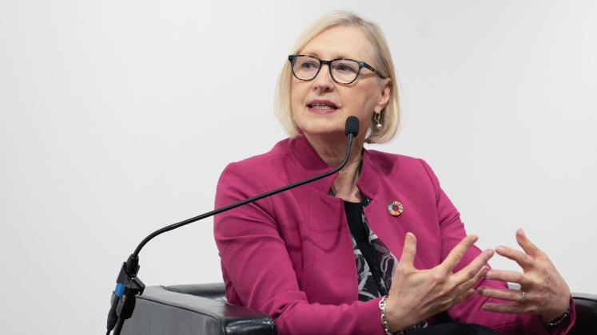Elizabeth Spehar (外交官・国連高官）

*　Key message and several points which I learned from her lecture.

1. **The key message is about the strategy（対策） for “Peace building”**by UN and her point of view based on facts.
2. **Need to be “innovative way of PRAGMATIC(現実的な）”**.Next list of words show her point of view.
3. Reality of Autocratic Peace(独裁的者的平和）,b)violent military sometimes brings peace and security,c)meaningful involvement by all level of people,d)need to hear their voice(敵の声） and bring women’s voice at the table e)comprehensive approach of **UN system（効率的な国連の包括的機能**）based on Security fund（費用）and commission(委員会）
4. To be successful necessary to be true “Multilateralism（多国間主義）”it is important to get approach from next ４　points.a) trust deficit(信頼関係の欠如）, b) double standard, c) women’s right,

d)recreate fundamental value.

ccajからの今回の参加者は、渋谷さんと熊田の2人だけでしたが、多くの方々との出会いがありました。

後程詳しくお話いたしますが、とりあえず当日の写真も一緒に転送いたします。

渋谷さん、本当にいろいろありがとうございました。

June 2,2024

Kyoko Kumada