The report from UNU open lecture on Thursday,18 January 2024
Title: “Japan-ASEAN (Association of South East Asian Nations) Bridges Event Series : Why Globalization Has Failed to Reduce Inequality”
Speaker: Professor Eric S. Maskin(Nobel Laureate)

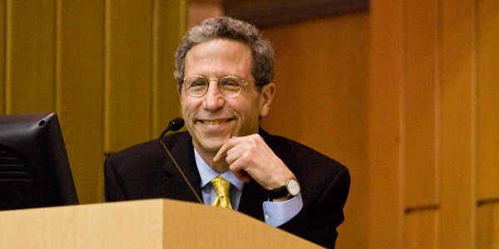Professor Erick S. Maskin

* My simplified summary became as follows. Even though detail calculation and context is
possibly wrong, but I feel I could found the way and the direction of the problem solving. I think that is so important and helpful for us to keep thinking the world issue.

- The short answer to the title : It is because distribution of low skill labor wage and high skill worker’s wage was not adequate. That gap increased the world’ division. When we think about the impact of technology to the world economy, the way of its impact is changing in the history . We can see that from the case of the history of China an India. The Industry Revolution first helped to make the gap small. But now it is necessary to educate low level wage workers to get high level skill and the make the society equal economically, we need the correction system by the financial help of inverters and government.
- “cross matching” という方法で、教育の産業（仕事）、所得の分配を理想的な方向、平等（square)へと導く具体的な数式の説明を、優しい英語で説明なさっていたのが、感動的でした。

最後に、昨日は、CCAJからは、渋谷さんが出席、会場でアシルさんとご一緒でした。
この内容を、今年のすわっ祭で、話し合えたらと考えてております。
残念なのは、渋谷さんが送ってくださった、国連大のチルチ先生とMaskin 教授、それから講座の中の数式の写真が今回はプリントできなかったことです。

January 19,2024
Kyoko Kumada

