The report from UNU conversation on the September 31,2023

**Title: “Peace-building in the waked of Ukraine and Sudan”**

**Speaker: Dr. Sukehiro Hasegawa**

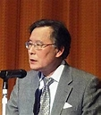 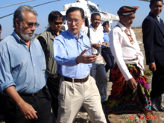

**Picture of Dr, Sukehiro Hasegawa**

**※** The key message of this lecture is what was like the role of UN to the world now and the past. How should be in the future. Dr. Hasegawa explained about it based on his rich experience of decades.

※ Summarized it into 3 points.

1. Good Pragmatism and Resiliency（回復力） are our strategy.

About how to get those 2, he explained about the power of philosophy(イマヌエル・カント）and world’s history based on his decades of activity in UN.

1. About pragmatism, he stressed on necessity of understanding of each countries unique situation of historical, political and other elements. (東ティモール等での経験に基づいて）
2. About the example of Sudan ,Gabon, other totalitarian countries in Africa and rest of the world, sometimes totalitarian system is effective for stability.

The power of the public decides which system they choose.

Lastly, it was the atmosphere of passionate and earnest discussion from all level of people like ambassadors , professors and students.

August 31,2023

Kyoko Kumada