[Report from UNU Conversation Series on November 28,2023]

**Title: “ Food Systems in Africa: The Role of Food Sovereignty in Promoting Sustainable Development”**

**The speaker; Dr. Ibrahim Mayaki**

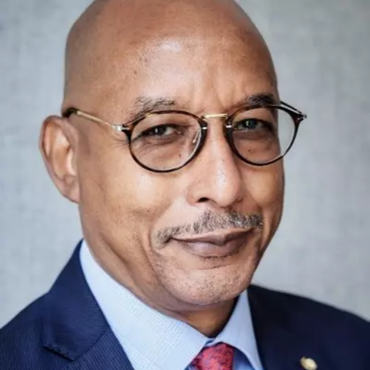 Dr. Ibrahim Mayaki

*The Key Message

Former prime minister of Nigel explained constructively and clearly about African food system and how prepared for future issue like increasing number of population , climate change and poverty issue. I would like to summarize it into 5 points according to his lecture.

1: The difference of “food security and food sovereignty”is **politics** is included in the latter.

2: About economy, it includes other social factors like education, social welfare and so on.

3: And also, the role of “African Union” is so important for making the right economical strategy.

4: The economical strategy of African Union and Dr. Ibrahim is focusing on “Agriculture”, because it is so productive to make small and middle scale businesses which will solve effectively the problem of “Job issue for African youth.

5:About the problem of “Corruption”, to avoid it making a GOOD institution for checking system is important.

大変、実用的な視点で、明解な説明でありながら、広い世界観を感じさせる、魅力的な講座だったと思います。

昨日は、ガボンのアシルさん、渋谷さん。越田さん、それから熊田と、久しぶりに賑やかな参加になりました。ご協力ありがとうございました

Kyoko Kumada