Report from UNU Conversation Series on Nov.9,2023

**Title: “”Global Crises and United Nominations Response and Innovations: Lessons Learned, Challenges and Prospects”, with Prof. Ibrahim Gambari**

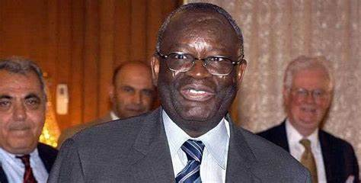　　　　　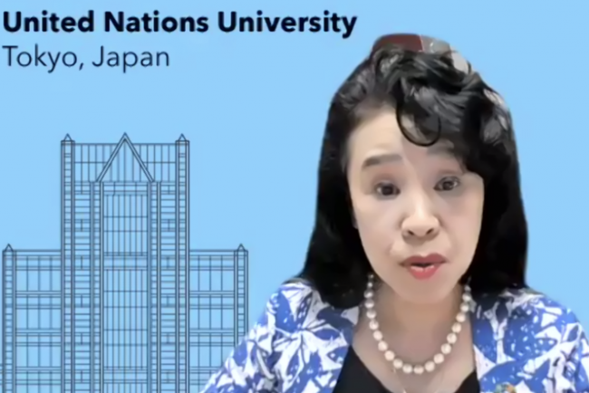

Prof. Ibrahim Gambari Prof. Shinobu Ymaguchi 国連大学

ナイジェリアのフラニ（支配層）の出身

Lecture of Yesterday was unusually warm and friendly atmosphere with many many jokes. This morning, I checked his background by internet then I understood no wonder the reaction of guest that night. I felt the spirit of remarkable “resiliency” in general. I summarized its key message into next 3 points.

1. UN is now facing two fronts. One is outside; Ukraine, Israel and those impacts. The other is inside which is structural functional problem.

（今、国連は内外に問題を抱えている。）

1. We can see the the power of resilience which comes from learning “experience”.

He talked about the case of Rwanda(Pref. Yamaguchi was in Rwanda just after Rwandan genocide) and Tanzania (one of the guest was from Tanzanian embassy). Both of the case shows” the power of resilient”. Now those victims became great leaders for peace building.（過去の犠牲者の平和構築の指導者の育てることに成功している。ルワンダとタンザニアのケース。）

1. What we can do ? Keep making effective “Pressure” fro multi-skilling way.

（多角的で効果的なプレッシャーを、問題の原因にかけ続けること。）

　　　　　以上です。　　　　　　　　　　　　　　　　　　　　　　Kyoko Kumada